Morgan Masapollo

10/19/2024

CS330 Comp Graphic and Design

7-1 Final Project

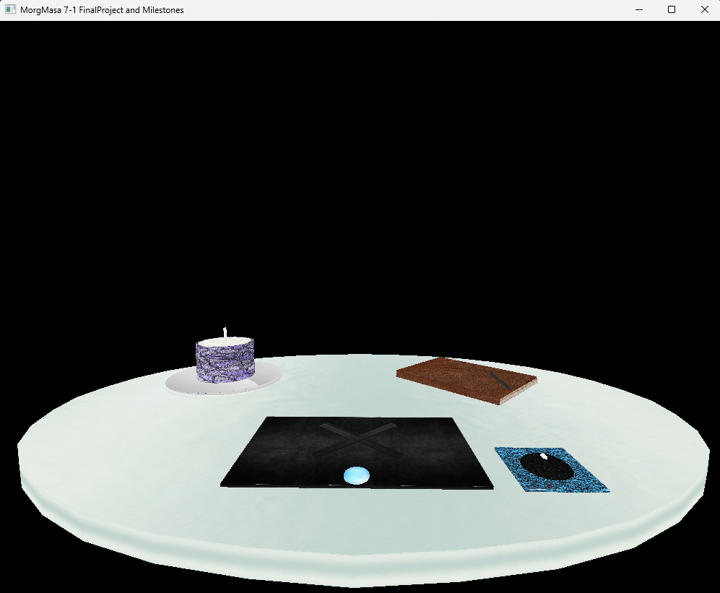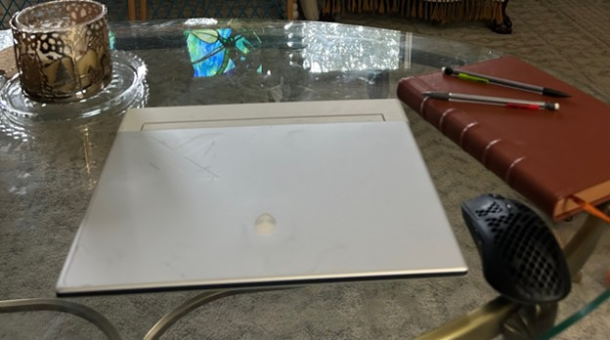

For this assignment I went with a simple scene of a study session set up. The original photo that served as my base is on the right and it shows my partner's laptop, mouse, planner, pencils, and a candle on a small glass tray. When I was going through the design process I wanted to design the scene to look appealing and make more sense. For instance I designed the laptop to be made out of dark metal instead of a white so that it wouldn’t blend in too much with the glass table. This also made it so if the user chose to utilize the camera controls or not they could look at the scene and tell what it is depicting. The mousepad I chose to add as I felt it was fitting to go along with the mouse to help add a pop of color to the scene. The blue was a good contrast with the black and adding the wave design I felt made sense as many mouse pads come with a design on them that matches the users preference. I also changed the depiction of the candle case because I felt the darker purple worked better with the colors and it helped the candle pop and stand out. The book I chose to make the same as I felt the brown leather also meshed well with the other colors and I think the aesthetic of leather journals are pleasing. Finally I only included one pencil and changed it to a pen because I felt that made more sense then having too many of the same pencils as normally someone only has one writing utensil to accompany their journal.

When it comes to navigating the scene, the user is able to move around utilizing their wasd keys for forward, backwards, left, and right. If the user wanted to just move the screen up and down in order to see everything from a direct view they can utilize the qe keys to move up or down. Further if the user wants to see different panel views of the scene, I incorporated the up, down, left, right arrow keys so that the user can simply click them in order to shift the camera view such as looking at the scene from above or directly on the side and then moving around this way. This lets the users explore the scene and see the different details within it. For instance in the photo on the left, the candle, mousepad, and pen are a little hard to see and make out what they look like, however utilizing the different angles and being able to get closer to the objects makes it easier for the user to see them and their designs.

I utilized a lot of the code from the opengl sample when constructing this project. One thing I changed was that I had it so the camera angle changes are done via the arrow keys. This is reusable and is more convenient as the camera angles are synced with the corresponding keys so the user doesn’t have to guess which key is needed for what angle and it is useful to use when creating code as it allows the user to be able to utilize both camera controls at the same time. The reach for the 1234 keys would require the user to take their fingers off the wasd keys however by inputting the controls to respond to the arrow keys instead of the number it allows the user to utilize both hands which can allow them to move around the scene faster.